CEN4010 Principles of Software Engineering

Spring 2021

Milestone 1 Project Proposal and High-level description

Team 16 - Milestone 1 - Covid Connection App

Team 16

William Medina

Matthew Maggio

Taylor Elliot

Yherzon Chura Ruiz

Ricardo Mesidor

February 16, 2021

**History table:**

|  |  |  |
| --- | --- | --- |
| **Date** | **Instructor’s Feedback** | **Date Revised** |
|  |  |  |
|  |  |  |
|  |  |  |
|  |  |  |

**Milestone 1**

1. **Executive Summary**

In November of 2019, the world fell into disarray when the corona virus spread, causing the world to go into lockdown. In this lockdown everything closed, while also forcing the world into isolation. Many people refrained from leaving their house, and with that people began suffering from depression, anxiety and many other symptoms that made it hard for them to interact in a normal day to day situation. We, engineers, have created a new platform called “Covid Connections” where people can connect with others. This platform's main goal is to connect people together during social distancing to help alleviate the stress that comes with being isolated. Our platform will have three different methods of communication, first being video call where the user can go in and pick a topic they would like to converse about and speak to others with knowledge on that specific topic. Second being voice call where people can speak with others without the need to feel anxiety from showing their faces, this could help people with severe anxiety and allow them to feel the relief that comes with simply talking about certain things. Lastly, we will have the option to chat. The platform will have no age restriction to allow many people of different ages to communicate with others. This application will be a place where people can come and communicate about several different hobbies and connect with people of different levels of experience, and a place where people can connect just to communicate about things currently going on in the world and in their life. Upon accessing the platform, you will be required to create a profile, where you must register using an email, age, and location. Within your profile you will be able to change your profile picture, edit several different sections within your profile page that will allow people to better understand you and your hobbies. The platform will also have a report button that will allow anyone to report other users for several different reasons, and a feedback button that will allow users to provide feedback on things they would like added to the platform or things that need to be changed for better performance when using the platform.

1. **Competitive analysis**

The current market for chat apps is currently in a boom since lockdowns started to take over the world. Many sites offer free text, audio and video calls with strangers just a couple of clicks away. The following are some of the largest chat services on the web, and how they compare to our application.

|  |  |  |  |  |  |  |
| --- | --- | --- | --- | --- | --- | --- |
|  | **Our App** | **TinyChat** | **Omegle** | **Chatroulette** | **ChatRandom** | **FaceFlow** |
| **User Profiles** | **✅** | **⚠** Optional | **❌** | **❌** | **⚠** Optional | **✅** |
| **Text, Audio, Video Chat** | **✅** | **✅** | **✅** | **✅** | **✅** | **✅** |
| **File Share** | **✅** | **✅** | **❌** | **❌** | **❌** | **✅** |
| **Chat Rooms with Predetermined Topics** | **✅** | **❌** | **❌** | **❌** | **✅** | **❌** |
| **Chat Rooms about Current News Feed** | **✅** | **❌** | **❌** | **❌** | **❌** | **❌** |

Although OUR APP will include instant text messaging, audio, and video call features, it will be different from the competition by providing chat rooms for exclusive topics while giving the participants a layer of trust through user profiles and backgrounds. Users will be able to share their common interests through file sharing, which can include documents, images, or videos. Lastly, in order to keep users engaged in our app, rooms devoted to current news and trending topics will be available for chatting.

1. **Data definition**

Catalog of Topics: A list of topics that a user can choose from.

Chat: Talk in a friendly and informal way.

Chat Room: A virtual room or place where people can meet and interact.

Connect Page: A user’s list of available rooms in which friends, favorites, and general topics rooms can be accessed.

Features: Distinctive attributes or aspects of something.

News Timeline Page (NTP): Page where news will be displayed in real time.

Notification: The fact of notifying someone such as a sound for an upcoming text message or a request.

Personal Account Page (PAP): A user’s profile after having signed up and being authenticated.

Request: An act for asking politely for something like joining a meeting or a friend.

User: A person who uses or operates something, especially computers.

User Records: Complete profile of each user in the system, including each user’s unique identifiers.

1. **Overview, scenarios and use cases**

Our aim with this project was to provide an easy-to-use web/mobile application to connect users through a social network. The features and functionality of the application will provide a clean interface for which the user can navigate with ease. The initial features of the application will be unavailable to the user until that user either logs in or creates an account. Once all the features of the application are accessible, the user will be directed to their account page showing their account information. The interface will allow users to communicate with each other multiple ways that are primarily focused on topic preferences. They will be able to connect to a random user or they will be able to search for other users via email, name, or number. Once a specific user is connected either randomly or by searching, the user has the option to send a friend request for which they will have the option to manage (add/delete) their friends. Users will also be able to view relevant and recent news articles in the “News Timeline Page”. An added functionality to that page will be to save an article to a favorites page to store and view later. The following use cases are shown below in a streamlined and more detailed figure, below.

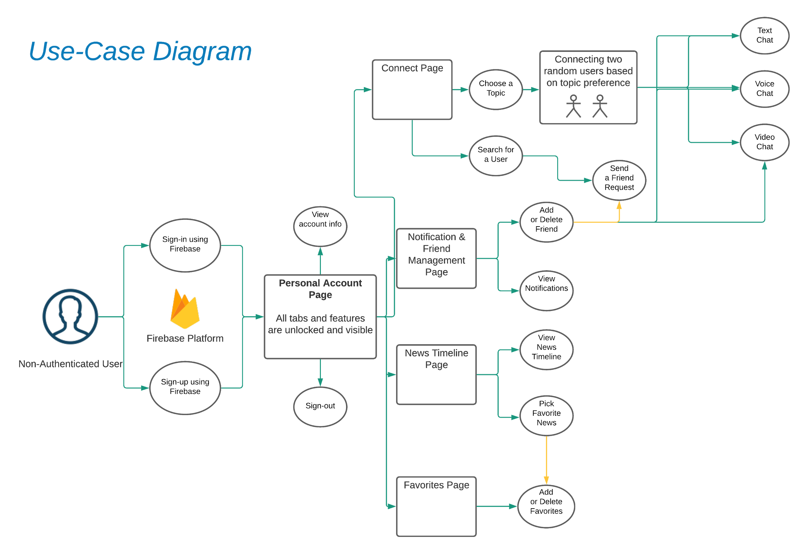

1. **Initial list of high level functional requirements**

List of Features

User profiles, Chat App, Audio call App, Video Call App, Catalog of topics, Search people, Records for each user, Notifications, Friend requests, News feature, Favorites, and a Chat Bot.

Based on the Use case diagram above we can first see that a Non-Authenticated User will first be instructed to either sign in or create an account if it is their first time accessing the platform. Upon creating and accessing the platform you will send to your profile page to add and edit your personal information, you will be able to add your date of birth, information about you and your hobbies, and change your profile picture and name, and will be able to sign out from here as well. After you are finished you can go to the home page where you will be able to connect to others based on the topic you choose, for example if you wanted to connect to the woodworking section, you would click the woodworking tab and then choose your form of communication whether it be voice, video, or chat. In the home page you will also be able to access your notifications and friends page, where you can change your notifications preferences and add friends, the home page will also have a favorites page based off of things you have favorited and a news timeline page.

To go further in each section of the home page we will begin with the connect tab, within the connect page you will be asked to choose a topic or search for a user. Here you will be able to connect to random people to connect with based on the topic you chose, when you have connected with someone you will be able to send them a friend request for future communication. The notifications and friends page allows you to add or delete people you have connected with and view any notifications. When you first enter the news timeline you will be asked to pick certain topics of news you would like to hear about when on the platform, after you pick which topics you would like you will be able to see any new and relevant news. Finally the favorites page allows you to add, delete, or go to any favorites you have saved.

1. **List of non-functional requirements**

a) Accessible in any browser (Chrome, Edge, Internet Explorer)

b) Compatible with either Android or IOS

c) Size is 116 MB (Megabytes)

i. App 115 MB

ii. Data 0.99 MB

iii. Cache 209 KB

d) Can be installed on Laptop, Desktop, Tablet and Phone

e) Users can

i. Texts

ii. Read and record Videos

iii. Send and receive Images

iv. Send and receive Photos

v. Read and record Voice messages

vi. Send and Accept Friend Request

vii. Add and Remove Friends

viii. Access breakout room using topics

f) Easy to access and safe to share documents

i. Create a username and password

ii. Enter Credential to log in

g) Friendly interface

i. Images

ii. Notification for incoming and outgoing messages

iii. Colors

1. **High-level system architecture**

**Overview of the High-level System Architecture**

HTML, CSS, and Javascript will be used as the front-end development of the application. The primary focus will be the development of a web app to support the full functionality specifications and user interface. The secondary objective will be to implement a mobile portion that will utilize the Android OS.

**Specific Implementation Software, Frameworks, and APIs**

Apache Cordova will be used for the mobile development aspect of the application. Cordova is a mobile development framework that utilizes web page languages such as HTML, CSS, and Javascript to create native applications across a variety of mobile platforms.

Android Studio will be used in conjunction with Apache Cordova to provide virtual emulating software. The Android virtual machine will mimic a functional Android device enabling the app to provide efficient, speedy, and real-time results to the end result of the back-end programming.

The user-creation and login features will be implemented using the Google Firebase platform. Along with account management features, the platform can also provide tracking statistics, reports and solutions for application crashes, and product launching support and functionality.

The APIs implemented in the project will cover functions such as authentication, text chat, audio and video calls in real time, notifications pop-ups, chat bots, and news feed.

* OAuth for user authentication.
* WebRTC for Audio and Video calls.
* Firebase Cloud Messaging SDK for popup notifications.
* Hangouts Chat Bot Service API for automated chatbots.
* Bing News Search API for news feed.

Although our team does not have experience with any specific framework, React.js will be the preferred web framework for this project since React.js appears to be the most wanted framework thanks to its ease of use and implementation as a Javascript library.

1. **Team**

Taylor Elliott- Product Manager - telliott2020@fau.edu

Skills- HTML, C, C++, microsoft word, and excel

William Medina- Scrum Master, Front End Team Lead - wmedina2018@fau.edu

Skills- C, C++, HTML, CSS, Microsoft word, Excel

Ricardo Mesidor- Back End Team Lead - rmesidor2020@fau.edu

Skills- C, C++, Python, Algorithm,

Yherzon Chura - Programmer - ychuraruiz2019@fau.edu

Skills- C, C++, HTML, CSS, Javascript, Java, JQuery, Json, MySQL, PHP.

Mathew Maggio - Github Master - maggiom2018@fau.edu

Skills -C, C++, HTML, CSS, Javascript, Java

We meet officially on Thursdays at 2:00 pm on Zoom every week.

1. **Checklist**

|  |  |
| --- | --- |
| Team decided on basic means of communication | DONE |
| Team found a time slot to meet outside of the class | DONE |
| Front and back end team leads chosen | DONE |
| Github master chosen | DONE |
| Team ready and able to use the chosen back and front-end frameworks | ON TRACK |
| Skills of each team member defined and known to all | DONE |
| Team lead ensured that all team members read the final M1 and agree/understand it before submission | DONE |